Final Project Design Phase
Computer Science - Week 11
Oct 3, 2026 - Version 0.0.4

For complete instructions and project ideas, refer to the assignment in Canvas. Specifically, review the final project requirements before you continue below. If you have not reviewed the project requirements in Canvas (you might have to go to the modules view and check the current or past week's content), you will not be able to properly complete the parts below. In addition, it may be helpful to review the information on this Drafter documentation page.

0) Project Planning and Preparation
Successful programmers spend time planning before they begin coding. After reviewing the project requirements, answer the following questions to help guide your design and development process.
- What concepts from class or previous assignments might help you complete this project? Which programming concepts (loops, conditionals, lists, classes, etc.) do you expect to use? What programming skills do you want to improve while completing this project?
I expect to use classes and imported libraries, since the data that this program utilizes will likely be too complex for base python functions
Recursion may also be helpful, and I am especially interested in it after the portion of the recursion assignment that asked us to use

- Which parts of the project do you expect to be the easiest for you? The hardest? Why?
I expect most of the LLM programing and design to be easiest, since it’s smart enough to do it on it’s own, but the hardest part is the lack of time that i have from other homework and assignments to work on my project.

- Even though you have not yet designed the final project, estimate which tasks will likely require the most time and effort? Which features or components should be implemented first?
I think trying to design the program visually would be difficult, as i am more used to having the simple layout of drafter
Different things to solve for the program via the imported libraries should be the easiest

- What distractions might interfere with your work and how will you minimize them? What resources will you need available while working? What questions, if any, do you still have about the assignment requirements?
I am generally easily distracted and there’s not much i can do about it; I am getting an ADHD evaluation next thursday.

1) Site Diagram
Create a mock-up of your planned website. We suggest you make the mockup on paper, although you can also use software like PowerPoint or Slides to make a mockup. There is other design software that could also be used, but we strongly encourage you to keep it simple. Do not spend more than 15-30 minutes detailing the mock-up. Your goal should be to make a very quick and dirty diagram, to show that you have some kind of idea.

We recommend drawing each page as a rectangle, and laying out the text, buttons, and other components inside. Then, use arrows to indicate links between pages. Label each page the way you will name each function, and then put labels on the arrows to indicate what the button links. Also write down any parameters that should come into the pages.

In addition to the pages and routes, write down what fields your `State` will have, both their names and types. Think clearly about what data will need to be persistent across the entire website.

Add photo(s) or screenshot(s) of your website mock-up and labeled diagram on the next page.

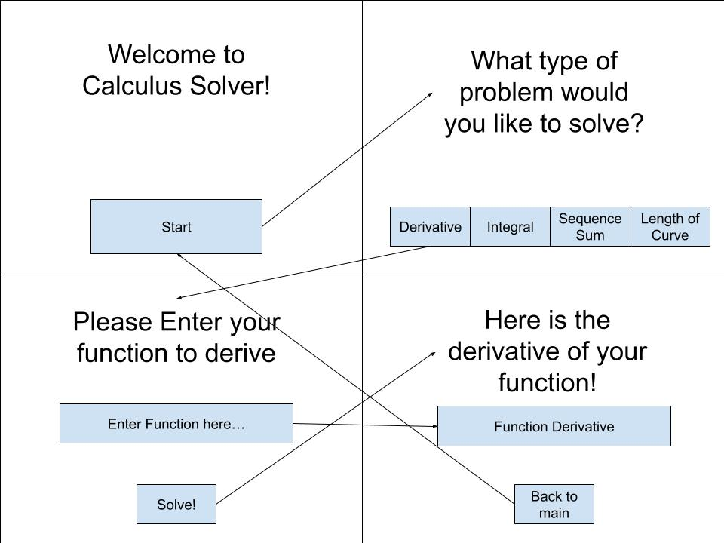
2) Implementing Requirements
This table should serve as a draft for how you will implement the requirements into your final project. You may change your ideas later on, but your final site must fulfill all the requirements.

Requirement | Implementation
Purpose/Functionality  A 1-2 sentence description of the purpose or functionality of your site | This program will perform calculus on functions imputed by the user
State Dataclass Attributes  Minimum of 4 attributes, one of which must be a list/dict of instances of your second dataclass.  Briefly describe each attribute, its type, and how it will be meaningfully modified throughout the site. | problems: Stores previously calculated problem, updated each time a new problem is solved  selected_function: Stores the function entered by the user, updated every time the user updates the function  x_value: Stores the x-value where the derivative is evaluated, updated every time the user submits an x-value  derivative_result: Stores the calculated derivative or evaluated result, updates every time a calculation is completed  current_page: Tracks which page the user is viewing, updated when a user navigates between pages
Second Dataclass  Your second dataclass, including its attributes, their types, and how they will be meaningfully modified (if they are modified) | Calculus problem: a dataclass representing functions  attributes:  function: str; the function itself  subproblem: a recursion of itself that contains an individual problem for each element
Routes (minimum 7)  The names of your route functions | - home  - function_selections  - derivative_input  - derivative_resultt  - integral_input  - integral_result  - sequence_input  - sequence_result  - arc_length_input  - arc_length_result  - problem_history
Pages (minimum 5)  A brief description of the pages in your site | 1. Home Page: App title, short description, and a button to get started  2. Calculator Selection Page: Buttons to choose derivatives, integrals, sequence sums, or arc length.  3. Derivative Calculator Page: Input for a function and an x-value, plus a calculate button.  4. Integral Calculator Page: Input for a function and integration bounds  5. Sequence Calculator Page: Inputs for the first term, common difference or ratio, and number of terms  6. Arc Length Calculator Page: Input for a function and the starting and ending x-values  7. Results Page: Displays the answer, calculation explanation, and a way to return to the calculator  8. Calculation History Page: Shows past problems solved and their solutions
User Input (minimum 3)  Description of user input components (TextBox, TextArea, CheckBox, or SelectBox) and their purposes  For more information on these input types, see Drafter Documentation. | There will be TextBoxes for each calculator page for users to input their functions onto, which will total 5 TextBoxes  There will also be another TextBox for each of the following above pages for the x value the user wishes to input
If Statements (minimum 3)  Brief description of what will be evaluated in your if statements and how they will meaningfully change the logic of the site | 1. Input validation: Check if the user entered a valid function or left the input blank. Display an error if it is invalid.  2. Operation selection: Check which calculator the user selected (derivative, integral, sequence sum, or arc length) and perform the corresponding calculation.  3. Calculation validation: Check whether the inputs are mathematically valid, such as ensuring the ending bound is greater than the starting bound or that the number of sequence terms is positive.
Loop (minimum 1)  This loop must iterate over the list/dict of dataclass instances in your State attribute.  Description of this loop and why it is meaningful to the site | One loop i plan to be using is a loop that does recursion to evaluate each branch of the calculus problem dataclass to evaluate each individual term and combine the results

LLM Conversation
If you used an LLM in any part of this work, copy and paste every part of that conversation below. Otherwise, you may be given a zero for the assignment. Obviously, these words will not all be yours, and this is the exception to the requirement at the top of this assignment that all responses be in your own words. If you did not use an LLM to assist you in this assignment, simply say so below.
added
selected_function Stores the function entered by the user User submits a function
x_value Stores the x-value where the derivative is evaluated User submits an x-value
derivative_result Stores the calculated derivative or evaluated result Calculation is completed
current_page Tracks which page the user is viewing User navigates between pages
error_message Stores errors, such as invalid mathematical input An invalid expression is submitted

This gives you six attributes, including a list of dataclass instances.
2. How they work together
Here's how I envision your application using those attributes:
Page 1
Start Page

Welcome message and a button to begin.

State: current_page = "home"

Page 2
Function Selection

Choose derivatives, integrals, or limits.

State: current_page = "selection"

Page 3
Derivative Input
Enter your function
x**3 + 2*x

Enter your x-value
2

Calculate Derivative

State: selected_function and x_value are updated.

Page 4
Results Page
Your derivative
3x² + 2
At x = 2: 14

State: derivative_result and problems are updated.

3. How this satisfies your State requirements
Your rubric requires:
- At least four State attributes.
- At least one list or dictionary of class instances.
- At least four attributes meaningfully modified in routes.
Here's how I would plan that:
State attribute Meaningful modification
problems Append a new CalculusProblem after a calculation
selected_function Update with the user's submitted function
x_value Update with the user's submitted x-value
derivative_result Update with the calculation output
current_page Update during navigation
error_message Update when input validation fails

You actually have six attributes that can be modified, so you have some flexibility.
4. One important mathematical distinction
You mentioned that users enter both a function and an x-value.

There are actually two different outputs you could display:
1. The derivative function: For example, the derivative of \(x^3+2x\) is \(3x^2+2\).
2. The derivative at a specific x-value: At \(x=2\), the derivative is 14.
I would display both. This makes your calculator more educational and gives the user a better understanding of what differentiation accomplishes.

\(f'(a)=\lim_{h\to0^+}\frac{f(a+h)-f(a)}{h}\)

\(\frac{f(2 + 2) - f(2)}{2} = 28\quad \text{error} = 16\)

\(h\)

.graphable-function-chartjs {
position: relative;
overflow: hidden;
touch-action: none;
}

.graphable-function-chartjs-tooltip {
position: absolute;
z-index: 1;
overflow: visible;
pointer-events: none;
}

.graphable-function-chartjs-guide {
position: absolute;
top: 0;
bottom: 0;
border-left: 1px dashed var(--border-heavy);
pointer-events: none;
}

.graphable-function-chartjs-hover-point {
position: absolute;
width: 8px;
height: 8px;
margin-left: -4px;
margin-top: -4px;
border: 1.5px solid var(--bg-primary);
border-radius: 9999px;
background: var(--learning-block-accent);
pointer-events: none;
}

.graphable-function-chartjs-reset {
position: absolute;
left: 12px;
bottom: 12px;
display: inline-flex;
align-items: center;
justify-content: center;
z-index: 2;
width: 32px;
height: 32px;
border: 1px solid var(--border-light);
border-radius: 9999px;
background: var(--bg-primary);
color: var(--text-primary);
box-shadow: 0 2px 8px
color-mix(in srgb, var(--text-primary) 8%, transparent);
padding: 0;
transition: opacity 160ms ease, transform 160ms ease;
}

Give feedback

5. My final recommendation
I would stick with these six State attributes:
- problems
- selected_function
- x_value
- derivative_result
- current_page
- error_message
One additional suggestion: eventually, you could make CalculusProblem support multiple operation types by adding a problem_type attribute. That way, the same dataclass could represent derivatives, integrals, and limits.

You don't need to make this more complicated than it is. This structure is appropriate for a CS1 project, satisfies your dataclass requirement, and gives every attribute a practical purpose.

Try to Rewrite the calculus problem dataclass to use recursion

One way to incorporate recursion is to make each CalculusProblem capable of containing a list of smaller CalculusProblem instances.

This creates a recursive dataclass: a problem can contain subproblems, which can themselves contain more subproblems.
1. Recursive CalculusProblem dataclass
@dataclassclass CalculusProblem: function: str x_value: float derivative: str explanation: str subproblems: list["CalculusProblem"]

The important part is:
subproblems: list["CalculusProblem"]

It allows an instance of the class to contain other instances of the same class.
2. Example of how it could work
Imagine a user wants to differentiate:
\[
f(x) = x^3 + 2x^2
\]

You could break that problem into smaller problems:
- Differentiate \(x^3\).
- Differentiate \(2x^2\).
- Combine the results.
Your data could look like this:
problem1 = CalculusProblem( function="x**3 + 2*x**2", x_value=2, derivative="3*x**2 + 4*x", explanation="Differentiate each term separately.", subproblems=[ CalculusProblem( function="x**3", x_value=2, derivative="3*x**2", explanation="Apply the power rule.", subproblems=[] ), CalculusProblem( function="2*x**2", x_value=2, derivative="4*x", explanation="Apply the power rule.", subproblems=[] ) ])

3. Where recursion becomes useful
You could write a recursive function that displays the entire solution process:
def display_steps(problem): print(problem.explanation) for subproblem in problem.subproblems: display_steps(subproblem)

This function:
1. Displays the current problem's explanation.
2. Iterates through its subproblems.
3. Calls itself on each subproblem.
4. Continues until it reaches a problem with no subproblems.
This is a meaningful use of recursion rather than simply adding recursion to satisfy a requirement.
4. How it fits your State dataclass
Your State dataclass could remain:
@dataclassclass State: problems: list[CalculusProblem] selected_function: str x_value: float derivative_result: str current_page: str error_message: str

Now your application can store complete problem histories, including the individual steps used to solve each problem.

My recommendation: I actually like this design better for your calculus application. It gives you a way to represent step-by-step solutions hierarchically, and it could eventually support more complicated differentiation problems involving multiple rules.

One caution: recursion is an additional programming concept. Make sure you understand the base case (subproblems=[]) and recursive case (calling display_steps on each subproblem), since you'll want to document how it works.

What route functions could i use based off of the plan i have said already? I plan to also include integrals, sum of sequences and length of curve

Based on your plan, I would organize your Drafter application around one main selection page and five calculator sections, with separate result pages for each calculator.

Since you're including derivatives, integrals, sums of sequences, and arc length, you have enough functionality to create a fairly substantial application.
1. Recommended route functions
I would use these 11 routes:
Route function Page Purpose
home Start Page Introduces the application
function_selection Function Selection Displays the available calculus operations
derivative_input Derivative Calculator Accepts a function and x-value
derivative_result Derivative Results Displays derivative and evaluated result
integral_input Integral Calculator Accepts an integrand and integration bounds
integral_result Integral Results Displays the integral and its evaluated result
sequence_input Sequence Calculator Accepts a sequence and number of terms
sequence_result Sequence Results Displays the sum of the sequence
arc_length_input Arc Length Calculator Accepts a function and interval
arc_length_result Arc Length Results Displays the calculated arc length
problem_history History Displays previously calculated problems

This gives you 11 routes and 11 meaningful destinations.
2. What each calculator should accept
I would keep the input pages consistent so users understand how to operate your application.

1. Derivatives
Relatively easy
Find the derivative of a function.

Suggested inputs:
- Function: x**3 + 2*x
- X-value: 2
Suggested outputs:
- Derivative function
- Derivative evaluated at x = 2
- Optional graph

2. Integrals
Moderate
Calculate indefinite or definite integrals.

Suggested inputs:
- Function: x**2
- Lower bound: 0
- Upper bound: 3
Suggested outputs:
- Antiderivative
- Definite integral value
- Optional shaded graph

3. Sum of Sequences
Relatively easy
Calculate the sum of a sequence over a specified number of terms.

Suggested inputs:
- First term
- Common difference or ratio
- Number of terms
Suggested outputs:
- Individual sequence terms
- Total sum
- Whether the sequence is arithmetic or geometric

4. Arc Length
More challenging
Calculate the length of a curve over an interval.

Suggested inputs:
- Function: x**2
- Starting x-value
- Ending x-value
Suggested outputs:
- Arc length integral
- Calculated arc length
- Optional graph

3. How I would organize your State dataclasses
Since you previously wanted recursion in your CalculusProblem dataclass, I would preserve that idea.

Here's a possible structure:
@dataclassclass CalculusProblem: problem_type: str expression: str inputs: list[float] answer: str explanation: str subproblems: list["CalculusProblem"]@dataclassclass State: problems: list[CalculusProblem] selected_function: str selected_operation: str input_values: list[float] result: str current_page: str error_message: str

What each State attribute does
Attribute Purpose
problems Stores completed calculations
selected_function Stores the mathematical expression
selected_operation Stores derivative, integral, sequence, or arc length
input_values Stores x-values, bounds, and other numerical inputs
result Stores the calculation result
current_page Tracks the current application page
error_message Stores input or calculation errors

This is particularly useful because you can reuse the same State attributes across all four calculators.

For example, selected_operation could contain "derivative" or "integral", while input_values stores the appropriate numerical inputs for that operation.
4. How your routes would work together
Here is the overall navigation structure:
Home

home()

Function Selection

function_selection()

Derivatives

derivative_input()

derivative_result()

Integrals

integral_input()

integral_result()

Sequences

sequence_input()

sequence_result()

Arc Length

arc_length_input()

arc_length_result()

Problem History

problem_history()

The results pages should also have buttons to return to their respective input pages or go back to function selection.
5. A few important design decisions
There are three things I would consider before you start coding.

1. Reuse your input and result logic.

You don't need four completely different calculation systems for displaying results. Each result page can follow the same general structure:
- Display the original expression.
- Display the calculated result.
- Display an explanation.
- Save the problem in State.
2. Don't make arc length your first calculator.

Arc length is more complicated because it involves differentiating a function, squaring the derivative, adding one, taking a square root, and integrating over an interval.

I would develop in this order:
1. Derivatives
2. Integrals
3. Sum of sequences
4. Arc length
3. Be careful with arbitrary user input.

If you're using SymPy, expressions like x**2 are convenient, but you should validate inputs and handle unsupported expressions gracefully. Also test SymPy compatibility with your Drafter/Pyodide environment before committing to it.

My overall recommendation
I think your project should have these four main calculators, a home page, a selection page, and a history page.

That gives you a coherent application with 11 routes, a recursive dataclass, several meaningful State attributes, and plenty of opportunities to demonstrate loops, conditionals, and input fields.

One final idea: Consider calling the application Calculus Companion or CalcHub. It gives the project a more polished identity than simply calling it a derivative calculator.

Based off those routes, what pages should i include?

Based on your planned routes, I recommend including 8 main pages. Some pages can have multiple routes, such as separate input and result pages for each calculator.
Recommended pages
Page What it should include Routes
1. Home Page App title, short description, and a button to get started. home
2. Calculator Selection Page Buttons to choose derivatives, integrals, sequence sums, or arc length. function_selection
3. Derivative Calculator Page Input for a function and an x-value, plus a calculate button. derivative_input
4. Integral Calculator Page Input for a function and integration bounds. integral_input
5. Sequence Calculator Page Inputs for the first term, common difference or ratio, and number of terms. sequence_input
6. Arc Length Calculator Page Input for a function and the starting and ending x-values. arc_length_input
7. Results Page Displays the answer, calculation explanation, and a way to return to the calculator. derivative_result, integral_result, sequence_result, arc_length_result
8. Calculation History Page Displays previously completed calculations and their results. problem_history

How the pages connect
Here is the navigation flow I recommend:
Home Page

Calculator Selection

Derivative Calculator

Integral Calculator

Sequence Calculator

Arc Length Calculator

Results Page

Calculation History

A few additional suggestions
- Put a navigation bar on each page with links to Home, Calculators, and History.
- Make the results page show both the final answer and how the answer was calculated.
- Give users a button to calculate another problem without returning to the home page.
- Keep the four calculator input pages visually consistent so the application is easier to build.
One important distinction: You can have 8 pages while still having 11 routes. For example, all four result routes can lead to the same Results Page, which displays different content depending on the selected operation.

This structure should give you enough pages and routes for the project requirements without making the application unnecessarily complicated.

What are 3 if statements i could use? You only need to summarize

1. Input validation: Check if the user entered a valid function or left the input blank. Display an error if it is invalid.

2. Operation selection: Check which calculator the user selected (derivative, integral, sequence sum, or arc length) and perform the corresponding calculation.

3. Calculation validation: Check whether the inputs are mathematically valid, such as ensuring the ending bound is greater than the starting bound or that the number of sequence terms is positive.

Final Submission
When you are finished, download this file as a Word Document (docx) and upload the file to the appropriate assignment on Canvas.
note: thank you so much for allowing AI on this project! I have next to no time to work on anything other than my usual homework, especially with how attention deficit i am, which significantly increases how much time i will spend on my other assignments compared to how much time people usually spend; Thank you !!!!!!!!

